Team508: Structural and Thermal Management of an Automotive Battery

Concept Generation
Taylor Bethmann
Skyler Heft
Mark Hibyan
Austin Robertson
Kaleb Sands

FAMU-FSU College of Engineering
10/18/2019

Introduction
These concepts are generated through many methods to solve the problem presented in this project. The battery must be cooled while also being able to withstand forces during the race and last the whole race. Using the functions that were broken down before, we are able to solve the fundamental problems with our system and thus solve the overall problem. The important functions are mentioned in the morphological chart and solutions can be found in the concepts presented. The very basics of technology and layout are presented to give visual meaning to important concepts.
Concept Generation Methods
The main method of concept generation was through the morphological chart. The major functions are presented in bold at the top of the morphological chart. Below each are different solutions to these functions. From this, around 50 concepts were created through combining different function solutions together. The morphological chart creates new ideas by matching up concepts that may not have been thought about before. This propelled our thoughts and brainstorming process even more.
The next method was a crap shoot where the group met up and said anything that came to mind. These ideas were then further flushed out to get a good concept down. This generated around ten concepts as many were very basic and covered a broad range of concepts. The crap shoot opened up the group to many more ideas and thoughts leading us into brainstorming.

The last forty concepts or so were found through brainstorming. By writing down any ideas since the beginning of the semester, we were able to generate a wide range of concepts. After generating concepts the group critically thought about which ones would be feasible. The feasibility of concepts was decided as a group in order to include everyone’s thoughts and concepts they thought were best. From here, the group had to decide which are the top three concepts. This was done through further discussion and decision making by the group.

Five Medium Fidelity Concepts
- Cell Tab Cooling combined with passive air cooling in an aluminum container. Cell tab cooling can heat the battery up in cases of cold weather as well as cool the battery in case of battery overheating. The passive air cooling is a low cost way to cool the battery by running cool air over the battery. Aluminum of the container is a robust way to contain and can also act as a heat sink for the battery.
- Liquid cooled thermal management system, with a plastic casing. Liquid cooling is a very effective method of cooling works very well to maintain a temperature. Takes power and adds weight to the design. Plastic casing is non conductive in case of a break in the water cooling.
- Forced air convection by using radiator fans to force air into the vehicle, with a battery box opening for forcing air convection. This concept is similar to the high fidelity air cooling but incorporates a fan that could dissipate more heat at the expense of drawing power from the battery. A trade off that might be necessary based on cooling requirements.
- Phase Change Materials (PCMs) store thermal energy by the phase change from solid to liquid, since the latent heat from melting or freezing is at least 1-2 orders of magnitude higher than the energy stored by the specific heat, this method is not cost effective but would be an innovative way to thermally manage a battery.
- Cooling plates placed in between the individual modules in the battery pack. Cold plates provide localized cooling of power electronics by transferring heat from the device to a liquid that flows to a remote heat exchanger and dissipates into the ambient air outside of the battery box, the individual cooling plates can also be used to warm up the battery by adding a heater to the system.

Three High Fidelity Concepts
- Air cooled system using ambient outside air. This system has no added power requirements as energy capacity is a design constraint based on the competition rules. Draws ambient air from outside and cools battery modules to effective operating temperature. The motion of the vehicle provides air flow over the modules allowing for heat dissipation through forced convection. This low risk concept offers easy implementation, low maintenance, and low cost.
- Liquid cooled battery pack with compressive plates holding the modules tightly together. This method is useful for that the battery pack itself will be compact reducing the moment from dynamic loads but will take up space elsewhere on the vehicle. Liquid cooling is the most effective way to cool a battery as it is not dependent on outside temperatures and is proven to increase the total lifetime of the battery compared to other methods, this method will draw power from the battery.

- Passive air cooling with the box with heat exchanger qualities. The battery pack will dissipate heat via the box itself. The box will be designed to maximize surface area and allow air to flow around or through it while maintaining enclosure. Forced convection will be the main mode of heat transfer and will utilize a thermally conductive material to rapidly distribute the heat along its surfaces for dissipation.

Appendix
100 Concepts
- Aluminum box with slanted fins with openings in box
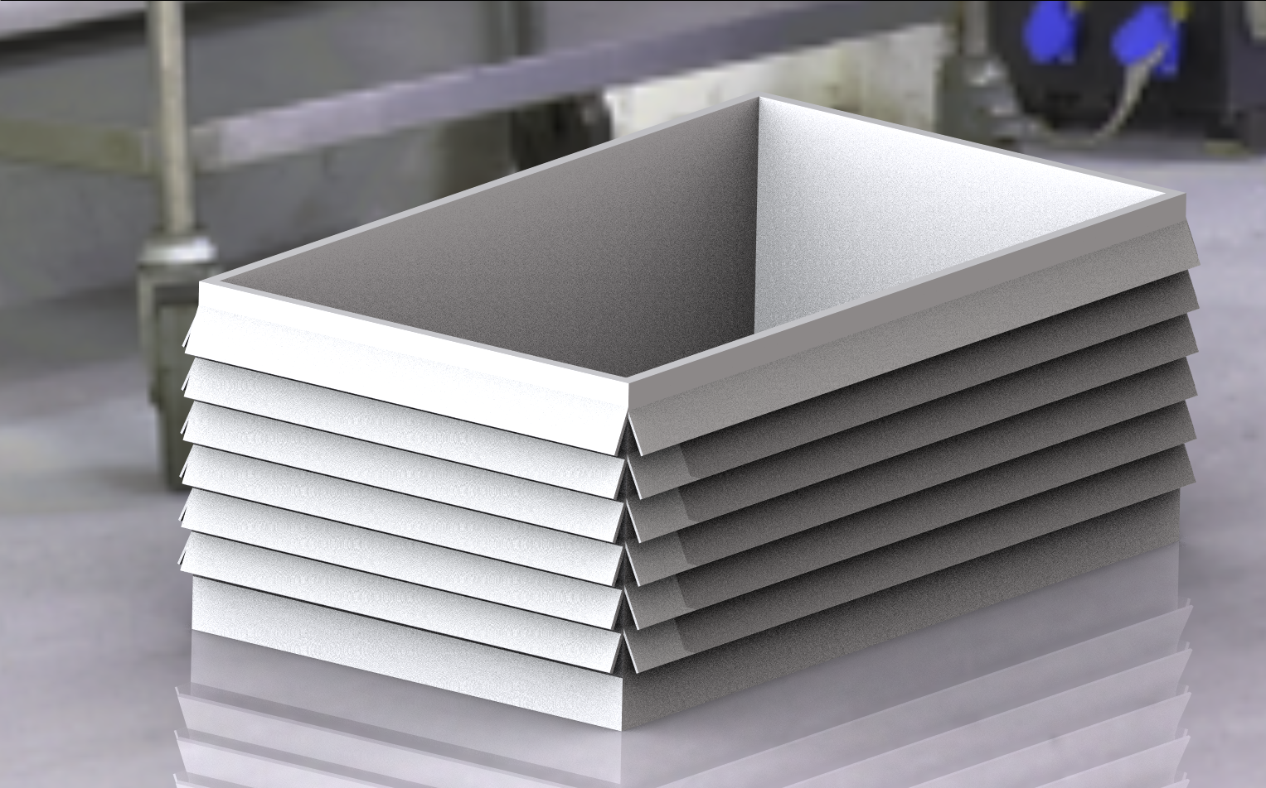
- Modules split in two boxes on each side of the car, wired to BMS in back
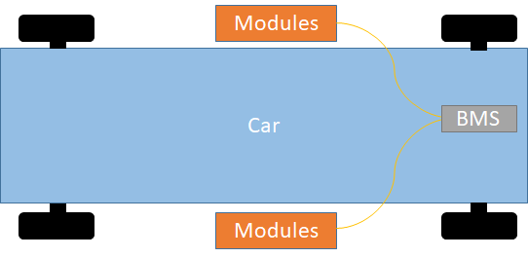
- Circular box with fins attached all around

- Liquid Helium heat exchanger for cooling - High heat capacity
- Liquid Nitrogen heat exchanger for cooling
- Refrigerant heat exchanger for cooling
- All components covered in water resistant material
- Radiator on outside that cools battery on inside
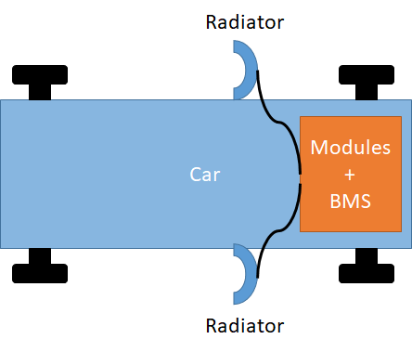
- Individual module sleeves that cool and protect modules
- Thermal cooling plate system for each stack of modules
- Cool water HX that coils around the modules
- High thermal conductivity heat dissipation
- Phase change material used for heat dissipation
- Evaporative Cooling system
- Lithium salt in an organic solvent to dissipate heat
- Active heat sink using fans
- Thermally conductive plates with fan
- Thermally conductive fins using forced convection
- Adiabatic fins using forced convection
- All components attached with epoxy resin
- Pack repels solar radiation absorption through reflective paint coating
- All components attached with high strength velcro
- System held together by compressive plates with a heat sink
- Sorbothane polyurethane for impact and vibration damping
- High strength composite enclosure
- Fill empty space of enclosure with dry ice each use for cooling
- Radiative cooling
- Cylindrical fins using forced convection
- System under tension and water cooled with tube and shell HX
- Mineral Oil soaked battery pack for high thermal management
- Forced induction via cold plate to draw heat from a battery
- Channel liquid flow underneath battery pack for cooling
- Phase change materials surrounding battery pack for thermal management and vibration damping
- Use heatsink to push warm temperature out of the battery pack.
- Only drive the car in places where there is no extreme temperatures
- Always drive the car really fast while the battery is exposed to the outside
- Cooling by flooding the battery with a dielectric oil which is then pumped out to a heat exchanger system.
- Forced air cooling using power from the generator freeing up the battery power
- Air conditioning system to force only cold air into battery box
- Indirect battery cooling using coolant and refrigerant based circuits
- No active cooling just force shutdown battery when battery temperature gets too high
- Removable cold blanket to wrap around battery pack.
- Reduce internal impedance to zero halting heat generation
- Diamond coated battery box for its high thermal conductivity
- Gold coated battery box for its high thermal conductivity
- Copper battery box for its high thermal conductivity
- Cycle batteries between use and non-use depending on the temperature of the battery
- Iron man arc reactor to power vehicle
- Run car in short bursts only to avoid overheating.
- Pre-cool air intake to keep the battery in acceptable temperatures.

Morphological Chart
Thermal Management
Heat Dissipation | Case Insulation
Fin Cooling | Cover in mesh material
Air Cooling | Place components in plastic box inside
Indirect Liquid Cooling | Fire retardant material
Direct Liquid Cooling
Fins with slats for air to come in

From this morphological chart of the thermal management there are 15 different thermal management concepts.

Physical Support
Access Outside Systems | Withstand Impacts | Seal Containment
Holes in box for each component | Aluminum box | Rubber seal
Wires through box | Steel box | Welded shut
Bluetooth communication | Hard Plastic | Plastic cover on top
 | Composites | Umbrella material over it

This morphological chart for the physical support produces 48 different physical support concepts.

